Operating System Review Problems
- What is a process？ Please draw a process state transition diagram with nine states in Unix SVR4?
- Illustrated some scenarios where process switch occur?
- Illustrated some scenarios where process should blocked?
- Suppose there are three processes running in an operating system with multithreading as following:
Process ID | Threads
A | T11, T12
B | T21, T22
C | T31, T32
If the multithreading is supported by user-level implementation and thread T11 is blocked, which thread may be scheduled to run next? If the multithreading is supported by kernel-level implementation, which thread may be scheduled to run next?
- What is race condition? Give a program implementation to demonstrate the mutual exclusion enforced by Test and Set (or exchange) instruction or by semaphore?
- Consider the following program:
boolean blocked[2];
int turn;
void P(int id)
{
while (true) {
blocked[id] = true;
while (turn != id){
while (blocked[1-id]) /* do nothing */;
turn = id;
}
/* critical section */
blocked[id] = false;
/* remainder */
}
}
void main()
{
blocked[0] = false;
blocked[1] = false;
turn = 0;
parbegin(P(0), P(1));
}
This software segment is the solution to the mutual exclusion problem for two processes. Find a counterexample(反例) that demonstrates that this solution is incorrect.
考虑进程0执行到blocked[id] = true这个语句是发生了进程切换，操作系统调度进程1运行。这种情况下会导致进程0和进程1同时进入临界区。
- Give a solution to bounded producer-consumer problem with semaphore.
- What is deadlock?
- Banker algorithms? Safe state/unsafe state

- Address mapping in paging system:
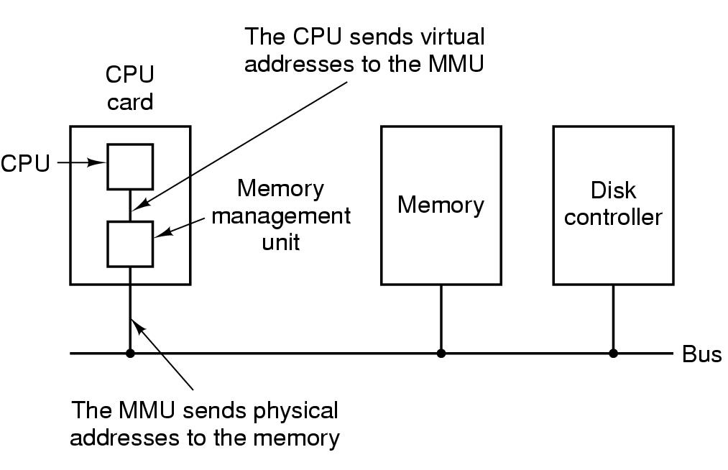
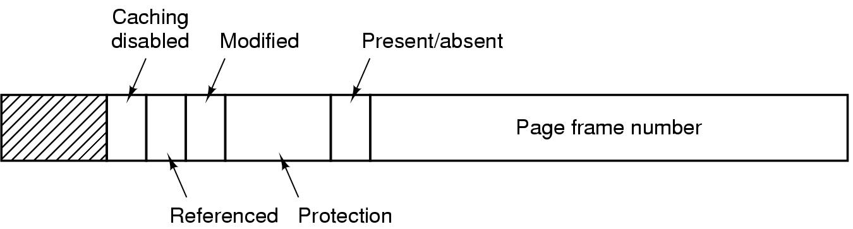
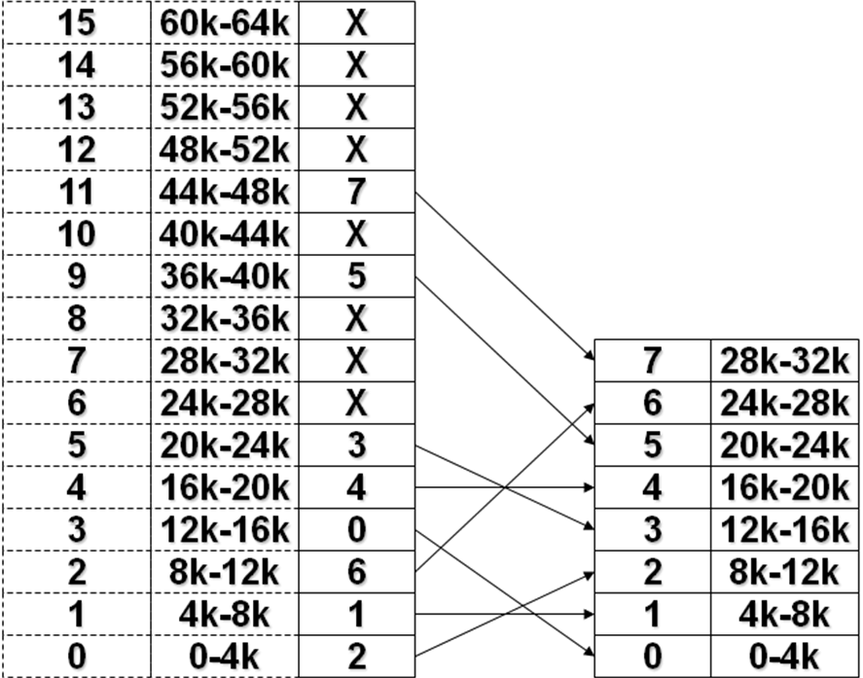
- What is TLB?
- Page replacement algorithms (Optimal/LRU/FIFO/CLOCK) in paging system.
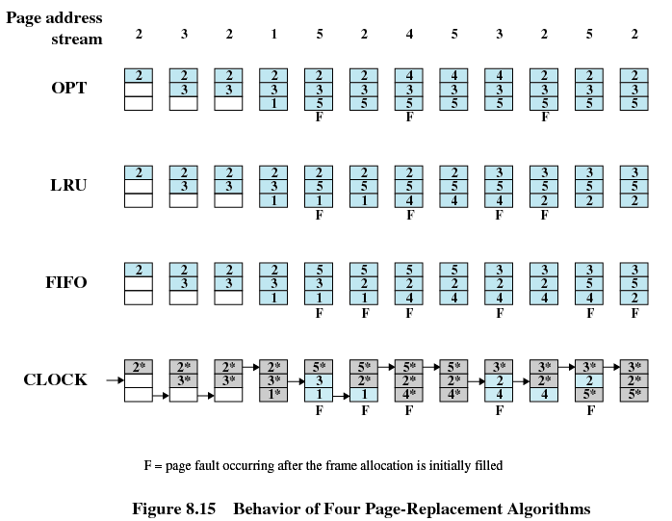

LRU:
- Replaces the page that has not been referenced for the longest time
- By the principle of locality, this should be the page least likely to be referenced in the near future
- Each page could be tagged with the time of last reference. This would require a great deal of overhead

CLOCK:
- Additional bit called a use bit
- When a page is first loaded in memory, the use bit is set to 1
- When the page is referenced, the use bit is set to 1
- When it is time to replace a page, the first frame encountered with the use bit set to 0 is replaced.
- During the search for replacement, each use bit set to 1 is changed to 0
- What is preemptive or nonpreemptive scheduling decision mode? How to compute turnaround time in different short-term scheduling algorithms?
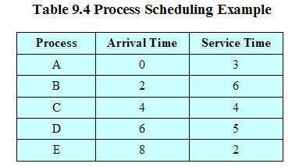

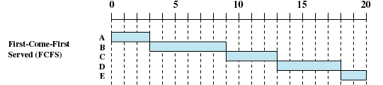

Round Robin
Proc. Number | Creation Time | Required Computing Time
1(A) | 0 | 5
2(B) | 1 | 4
3(C) | 2 | 3
4(D) | 4 | 6
5(E) | 5 | 4
- Draw the diagram of scheduling sequence for each process.
根据题意可知采用的是分时调度，时间片为1单位时间，应详细给出每个任务被调度的时序图。
提示：要绘制进程的调度时序图，要清楚地知道就绪队列中的进程是如何排队的。要注意到，在RR调度过程中只有以下三个时间点就绪队列可能会发生变化:
1) 一个新进程到达；
2）一个进程时间片用完；
3）一个进程运行结束；
可以列一个表，给出关键时刻就绪队列的变化，如下：
时刻 | 事件 | 调度之前的就绪队列 | 调度程序选择的进程（处理器上运行） | 调度之后的就绪队列 | 执行时间
0 | A到达 | A | A |  | 0
1 | B到达，A时间片用完 | B->A | B | A | A:1(1)
2 | C到达，B时间片用完 | A ->C->B | A | C->B | B:1(1)
3 | A时间片用完 | C->B->A | C | B->A | A:1(2)
4 | D到达，C时间片用完 | B->A->D->C | B | A->D->C | C:1(1)
5 | E到达, B时间片用完 | A->D->C->E->B | A | D->C->E->B | B:1(2)
6 | A时间片用完 | D->C->E->B->A | D | C->E->B->A | A:1(3)
7 | D时间片用完 | C->E->B->A->D | C | E->B->A->D | D:1(1)
8 | C时间片用完 | E->B->A ->D->C | E | B->A->D->C | C:1(2)
9 | E时间片用完 | B->A ->D->C->E | B | A->D->C->E | E:1(1)
10 | B时间片用完 | A->D->C->E->B | A | D->C->E->B | B:1(3)
11 | A时间片用完 | D->C->E->B->A | D | C->E->B->A | A:1(4)
12 | D时间片用完 | C->E->B->A->D | C | E->B->A->D | D:1(2)
13 | C运行结束 | E->B->A->D | E | B->A->D | C:1(3)
14 | E时间片用完 | B->A->D->E | B | A->D->E | E:1(2)
15 | B运行结束 | A->D->E | A | D->E | B:1(4)
16 | A运行结束 | D->E | D | E | A:1(5)
17 | D时间片用完 | E->D | E | D | D:1(3)
18 | E时间片用完 | D->E | D | E | E:1(3)
19 | D时间片用完 | E->D | E | D | D:1(4)
20 | E运行结束 | D | D |  | E:1(4)
21 | D时间片用完 | D | D |  | D:1(5)
22 | D结束 | D | D |  | D:1(6)

根据上表可以给出相应的调度顺序，就很容易画出调度时序图。

(b) Compute turnaround time of each process, and then compute average turnaround time.
先计算出每个进程的周转时间，在此基础上计算平均周转时间。注意，周转时间是一个进程从被创建到运行结束的时间。
A的周转时间为16-0=16； B的周转时间为15-1=14；
C的周转时间为13-2=11； D的周转时间为22-4=18；
E的周转时间为20-5=15；
平均周转时间为（16+14+11+18+15）/5 = 74/5=14.8单位时间

- Why Disk cache is usually used in operating system?

- Disk arm scheduling algorithms
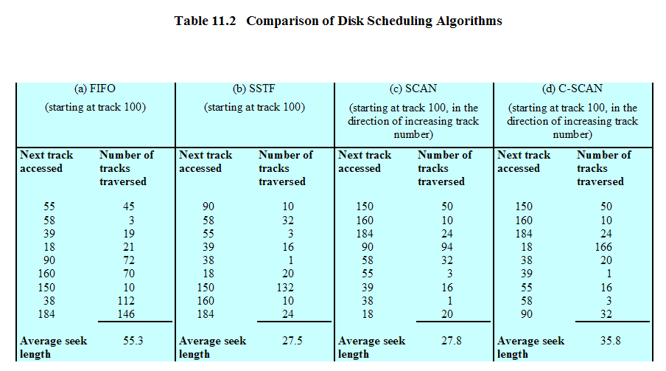
- What is Absolute path or relative path? Explain how file pathname /usr/ast/mbox is be parsed in Unix SVR4?
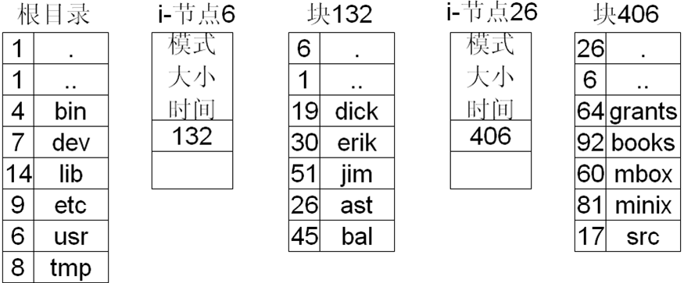
- Consider a UNIX-style i-node with 10 direct pointers, one single-indirect pointer, and one double-indirect pointer. Assume that the disk block size is 1 Kbytes, and that the size of a disk block address is 4 bytes. How large a file can be indexed using such an i-node?
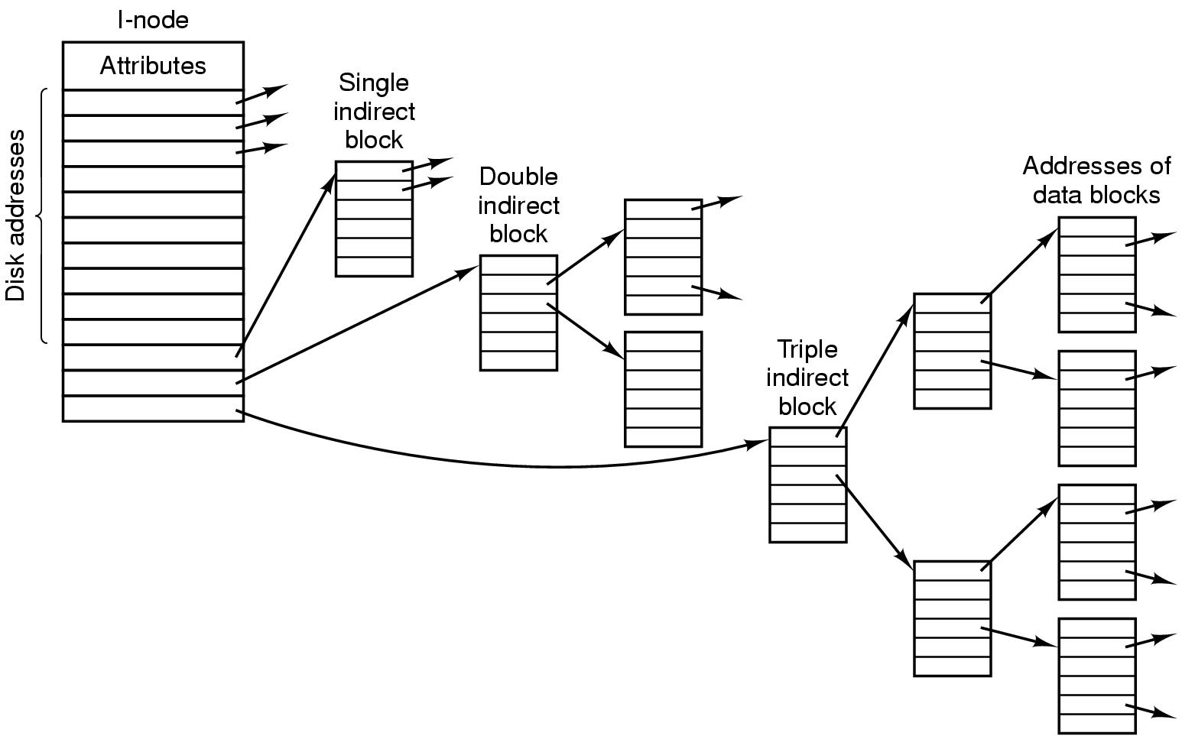
Disk block size = 1k = 1024 bytes
Disk block address size = 4 bytes
1024/4= 256
10 direct pointers : 10 * 1k = 10k
1 single indirect pointers: 256 * 1k = 256k
1 double indirect pointers: 256 * 256k
Maximum file size: 10k + 256k + 256*256k bytes

